**Pests of rice**

**Stem borer**

**Fig 1 Male and female moth of stemborer**

**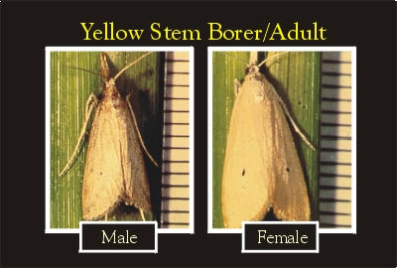**

**Fig 2 Stem borer egg mass**

**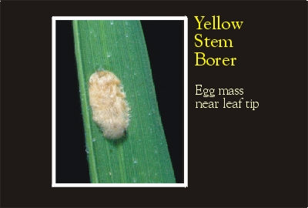**

**Fig 3 Stem borer caterpillar (larva)**

**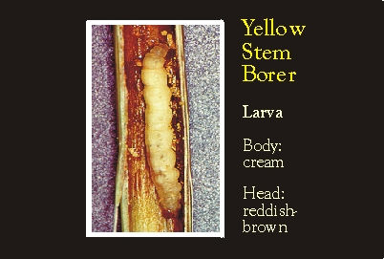**

**Fig 4 Stem borer pupa**

**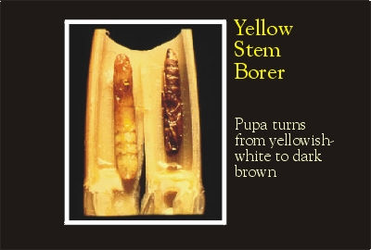**

**Fig 5 Dead heart symptom**

**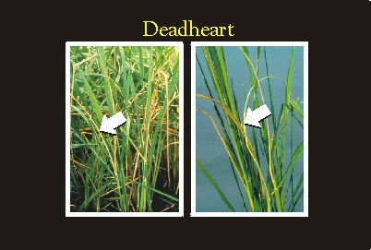**

**Fig 6 White ear head**

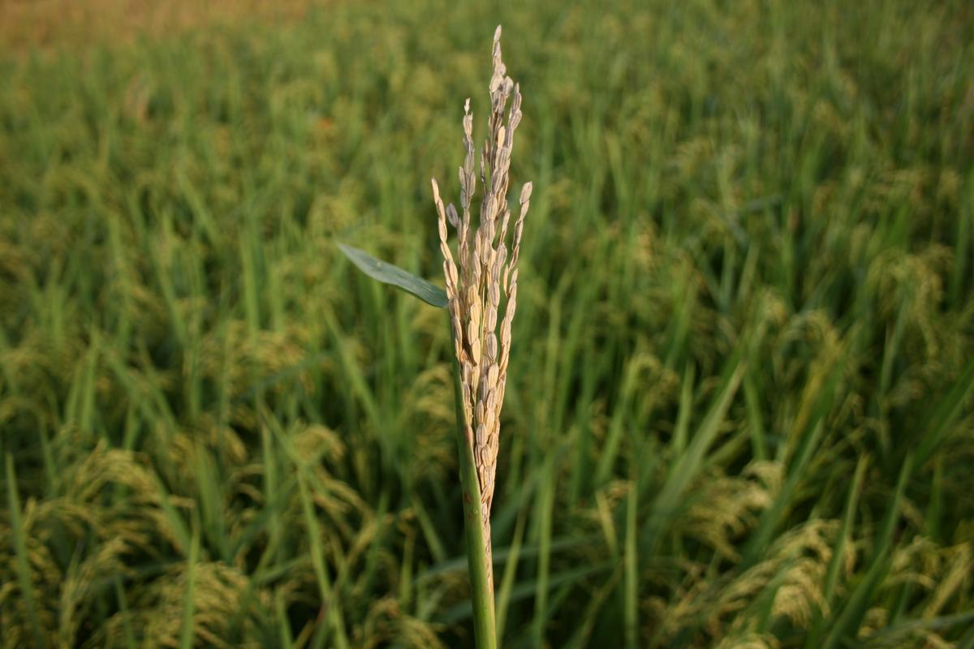

**Leaf roller**

**Fig 7**

**Leaf roller –Adult and eggs**

**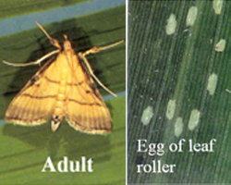**

**Fig 8**

**Leaf roller caterpillar webbing the leaf**

**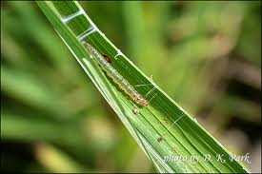**

**Case worm**

**Fig 9 Case worm- different stages**

**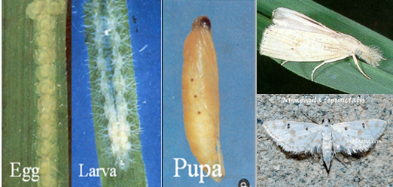**

**Fig 10**

**Larval cases floating on water**

**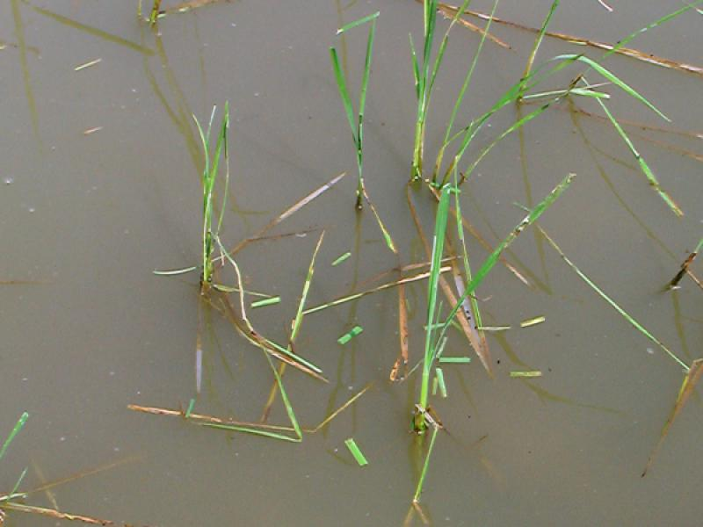**

**Fig 11 Case worm damage**

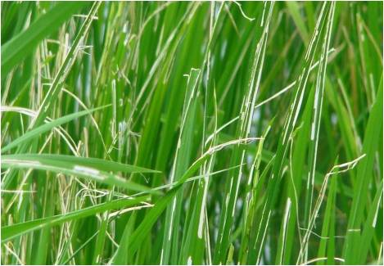

**Gall midge**

**Fig 12 Gall midge adult**

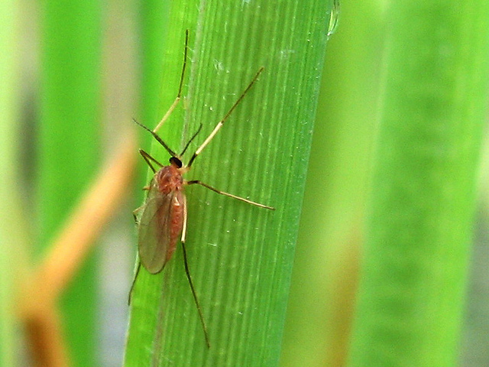

**Fig 13 Maggot inside the chamber**

**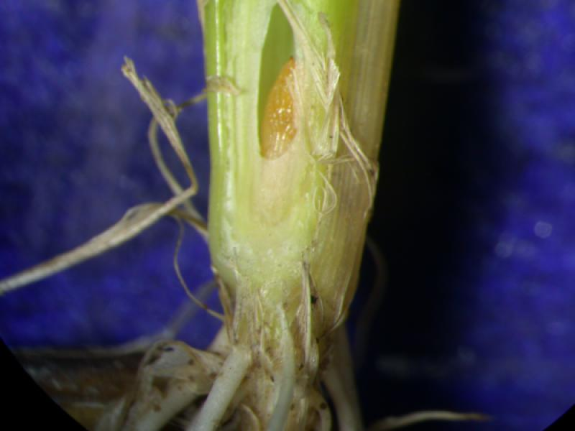**

**Fig 14 Silver shoot**

**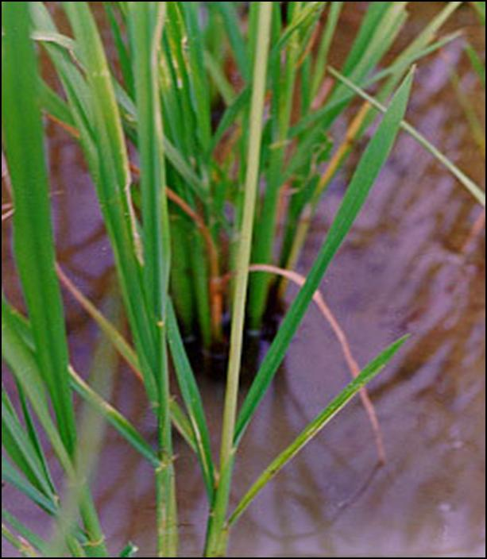**

**BPH**

**Fig 15 Two forms of BPH-**   truncate-**winged** '**brachypterous**' **winged** '**macropterous**' .

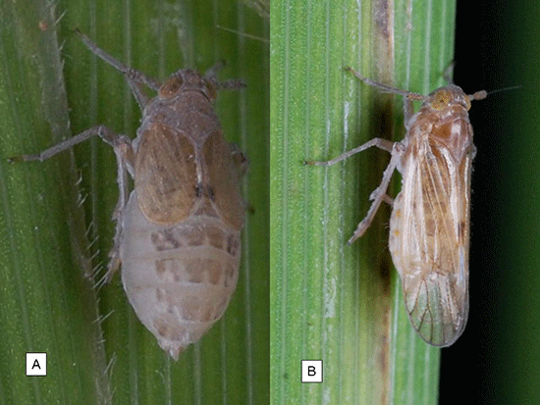

**Fig 16 BPH- Egg mass**

**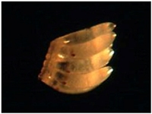**

**Fig 17 BPH- Field symptom**

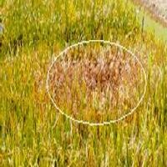

**Fig 18 BPH aggregation at the plant base**

**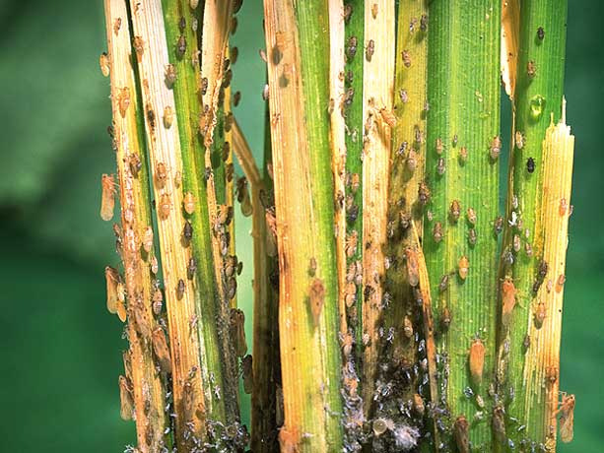**

**Fig 19 Hopper burn**

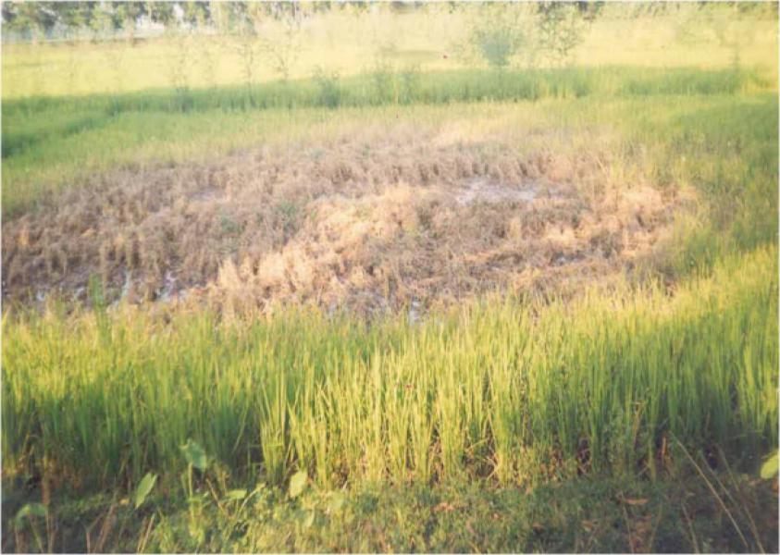

**Rice swarming caterpillar**

**Fig 20 Adult moth**

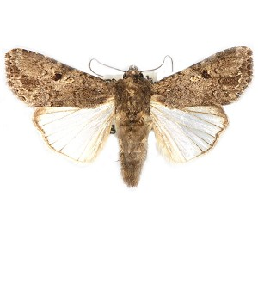**Fig 21 Caterpillars and pupae**

**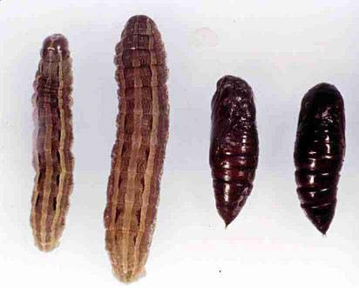**

**Fig 22 Symptom of damage**

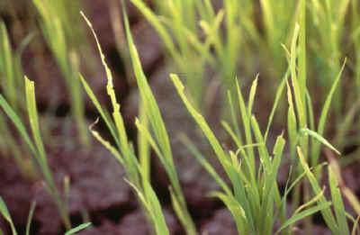

**Rice bug**

**Fig 23 Rice bug- nymph**

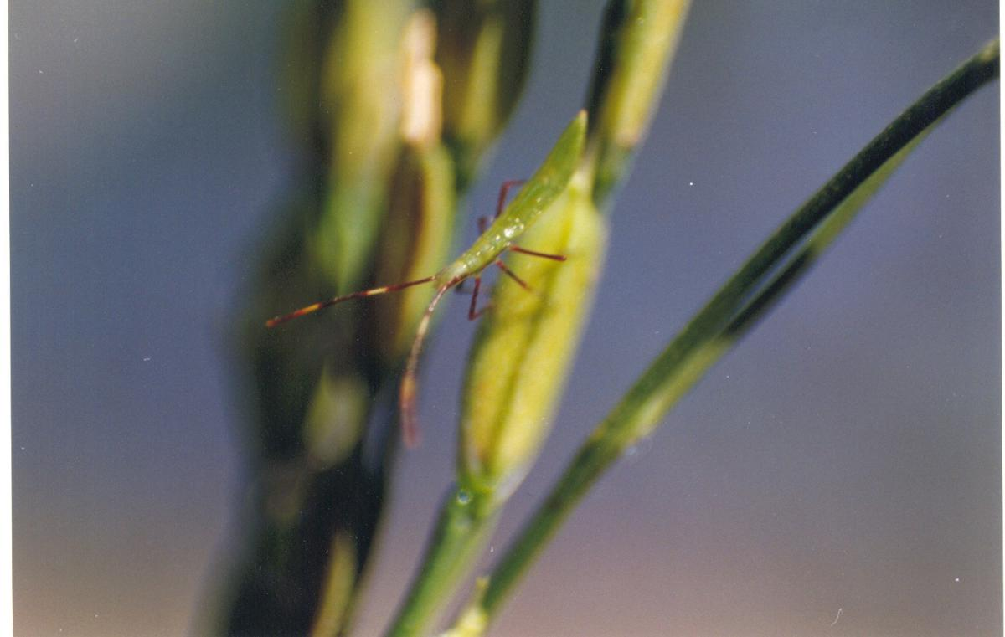

**Fig 24 Rice bug - Adult**

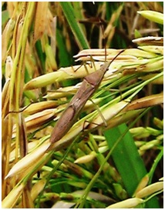

**Fig 25 Rice bug- Symptom of damage**

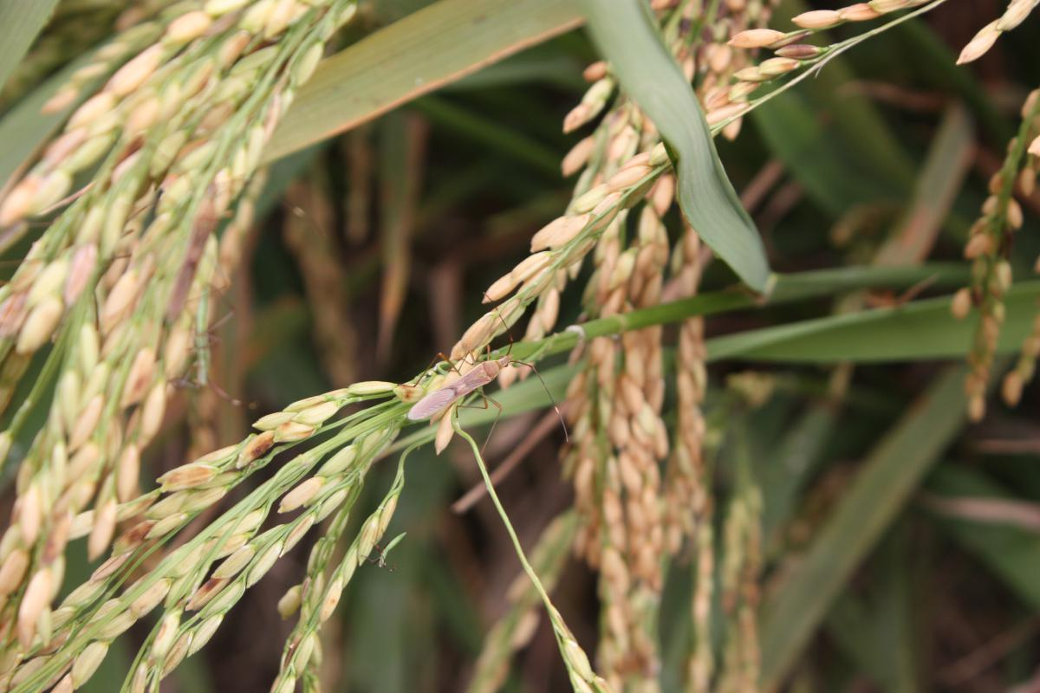

**Blue beetle**

**Fig 26 Rice blue Beetle (Leptispa)**

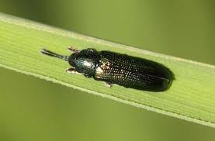

**Fig 27. Blue beetle –symptom of damage**

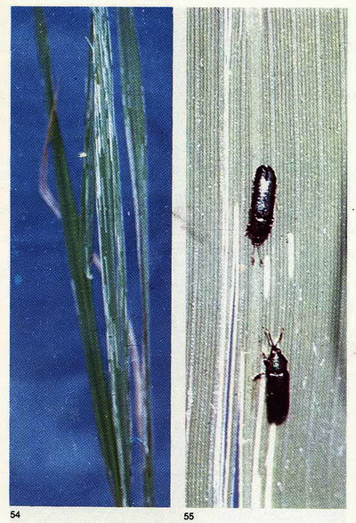

**Fig 28 Rice Hispa**

**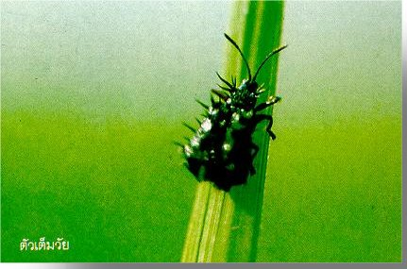**

**Fig 29**

**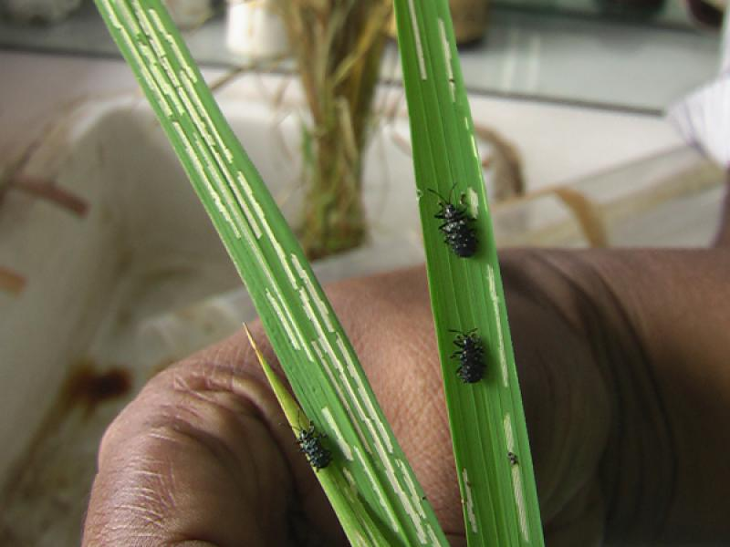**

**Thrips**

**Fig 30 Thrips**

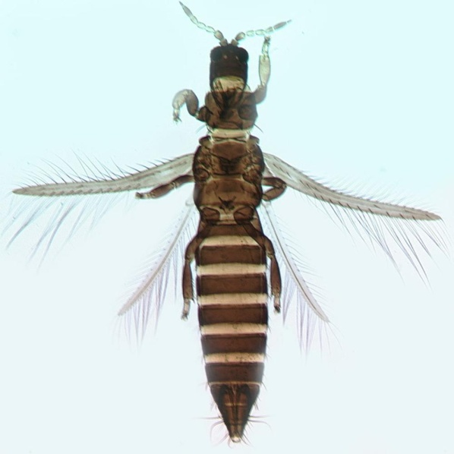

**Fig 31 Withering of leaves-Field symptom**

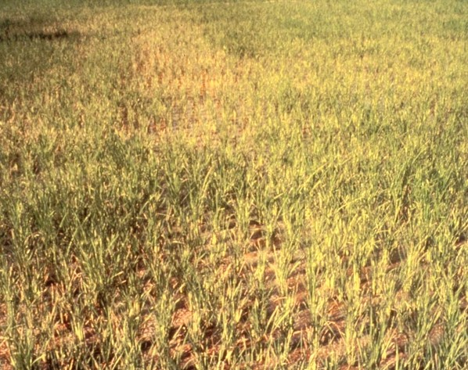

**Fig 31**

*Nephotettix virescens*

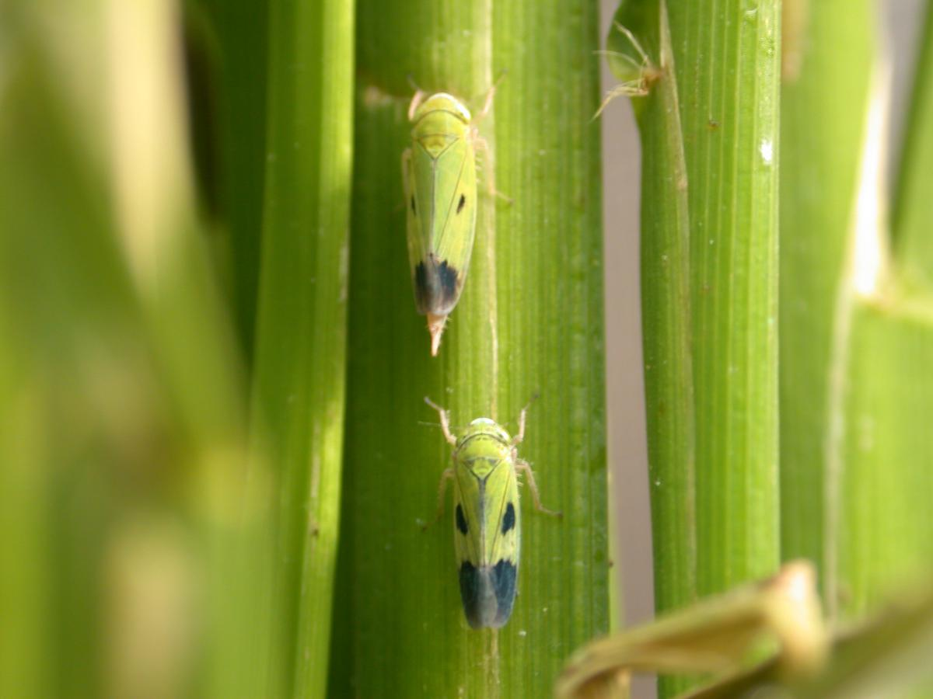

**Fig 32**

*Nephotettix nigropectus*

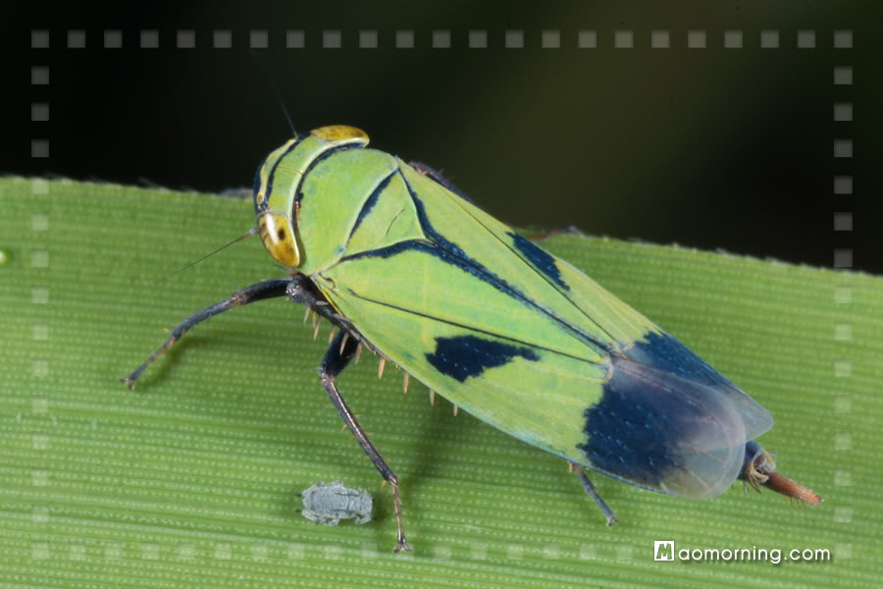

**Fig 33 Whorl maggot**

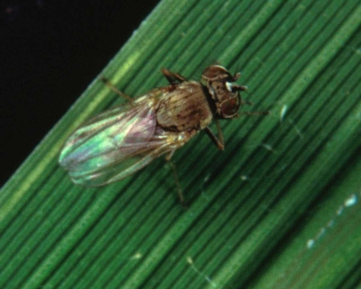

**Fig 34 Symptom of damage by whorl maggot**

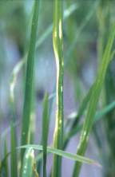

**Fig 35 Mealy bugs inside the leaf sheath**

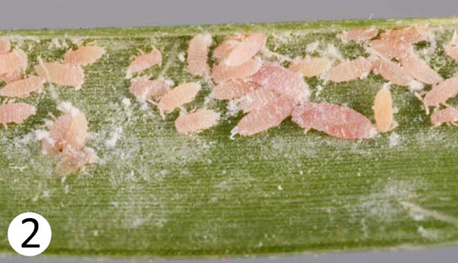

Common natural enemies of insect pests found in the rice ecosystem

1. Predators

Name of the predator Pests attacked

1. Lady bird beetles

|  |  |  |
| --- | --- | --- |
| 1. *Micraspis crocea* | http://www.knowledgebank.irri.org/ipm/images/stories/beneficials/image008.jpghttp://farm2.static.flickr.com/1084/857502810_4313e2fbd4_m.jpg  http://www.knowledgebank.irri.org/ipm/images/stories/beneficials/image1.jpg | Both adult and dark larva feed  on small Plant and leaf hoppers  and all types of exposed eggs  Lady bird beetle larvae are more  voracious than adults and consume 5-10 prey  (eggs,nymphs,larvae and adults) daily |
| 2.*Harmonia octomaculata* | http://www.rkmp.co.in/sites/default/files/Lady%20beetle_0.png |
| 3. *Menochilus sexmaculatus* | https://encrypted-tbn2.gstatic.com/images?q=tbn:ANd9GcSVgutTq3kAbECGRRcugaxbyVE3Aazp9Un6XXV9XE122CDSibl_yghttp://jnkvv.nic.in/IPM%20Project/natural_enemy/sexmaculata.jpg |
|  |  |  |

b.Ground beetles

|  |  |  |
| --- | --- | --- |
| *Ophionea nigrofasciata* | http://www.knowledgebank.irri.org/ipm/images/stories/beneficials/image010.jpg | Both shiny black larvae and reddish brown adults actively search rice canopy for leaf folder larvae and consume 3-5 larvae per day,adults also prey on plant hoppers |

c.Ripple bugs

|  |  |  |
| --- | --- | --- |
| *Microvelia douglasi atrolineata* | http://i1.ytimg.com/vi/E5d6PcM33Pw/hqdefault.jpg?feature=og | Small in size. Adults congregate to feed on plant hopper nymphs which frequently fall on to water. Nymphs also feed on hopper nymphs. Ripple bugs are more successful predators when attacking in groups. Each bug can prey 4-7 hoppers per day |

D. Water treaders

|  |  |  |
| --- | --- | --- |
| *Mesovelia vittigera* | http://farm2.staticflickr.com/1067/857510622_34aa4238e4_b.jpg | Mesovelia aduls and nymphs mainly feed on stem borer larvae and hoppers that fall on the water surface |

E. Water striders

|  |  |  |
| --- | --- | --- |
| *Limnogonus fossarum* | http://1.bp.blogspot.com/-kAv60_cMfDQ/UN7bOkRdOXI/AAAAAAAABPg/REqzaEnjh7s/s320/Limnogonus+fossarum+1.jpg | Adults and nymphs prey on rice hoppers ,moths and larvae that drop on to water surface. Each water strider feed on 5- 10 prey daily |

F. Mirid bugs

|  |  |  |
| --- | --- | --- |
| *Cyrtorhinus lividipennis* | http://www.knowledgebank.irri.org/ipm/images/stories/beneficials/image022.jpghttp://ricehoppers.net/wp-content/uploads/2012/07/pic-1.gif | They are Green and black bugs. Adults and nymphs become abundant in hopper infested fields-both wet as well as in dry lands. They search leaf sheaths and stem for hopper eggs and suck them dry .  Each predator consume 7-10 eggs or 1-5 hoppers in a day |

G.Assassin bugs

|  |  |  |
| --- | --- | --- |
| *Polytoxus fuscovittatus* | Images_1483ps_00341.jpg | They search rice canopy –mainly larvae of moths and butterflies. They inject a paralyzing toxin in to the body of the host. |

H.Damsel fly

|  |  |  |
| --- | --- | --- |
| *Agriocnemis* *pygmaea*  *A. femina femina* | http://www.asia-dragonfly.net/pics/a356/Agriocnemis_pygmaea.jpg  http://www.asia-dragonfly.net/pics/a340/AgriocnemisPygmaea4.jpg | Damsel fly nymphs are aquatic and climb up rice stems in search of hopper nymphs. Adults normally fly below rice canopy searching for flying insects as well as hoppers on plants |

1. Roving beetles

|  |  |  |
| --- | --- | --- |
| *Paederus fuscipes* |  | Beetles are found on rice bunds. They climb the rice plants in search of rice leaf hoppers and feed on them |



J. Dragon flies:

|  |  |  |
| --- | --- | --- |
| Dragon flies | http://upload.wikimedia.org/wikipedia/commons/e/e4/Dragonfly_ran-384.jpg | The adults fly over the rice canopy in search of flying insects .They also feed on plant and leaf hoppers. Nymphs are aquatic. They climb the stem to feed on plant hoppers. |

K. Crickets

|  |  |  |
| --- | --- | --- |
| *Metioche vittaticollis*  *Anaxipha longipennis* | http://i1.treknature.com/photos/14710/dsc_0759.jpg  image140.gif (485×446) | They feed on eggs of striped and dark headed stem borers, leaf folders, army worms, whorl maggots, nymphs of plant and leaf hoppers |

L.Meadow grass hoppers

|  |  |  |
| --- | --- | --- |
| *Conocephalus longipennis* | http://www.cbit.uq.edu.au/software/riceipm/keys/images/Orthoptera/orthop-ca.jpg | Predator of rice bugs and stem borer eggs as well as plant hopper and leaf hopper nymphs. Each predator consumes 3- 4 egg masses a day |

M. Spiders

|  |  |  |
| --- | --- | --- |
| Wolf spider: *Lycosa pseudoannulata* | http://farm2.staticflickr.com/1214/856668331_125f8b5fc6_m.jpg | Present both in wet and dry lands. Do not make webs but hunt prey directly. Feed on a range of pests. Spiderlings also attack plant and leaf hopper nymphs. It consumes 10-15 prey daily |
| Lynx spiders; *Oxyopes javanus*  *O.lineatipes* | http://spiderindia.lifedesks.org/files/spiderindia/plate_76-_oxyopes_javanus.jpg  http://farm2.staticflickr.com/1116/857529126_b61afcd646_s.jpg | Lives inside the rice canopy. Prefer drier habitats. They hide from the prey –mostly moths- and hunt them. They kill 2-3 moths daily |
| Jumping spiders: *Phidippus*.sp | http://i61.photobucket.com/albums/h73/padkison/PhidippusAudux2-1.jpg | They prefer dry land habitats. Remain with in rice foliage. They prey on green leaf hoppers and other small insects and may consume 2-8 a day |
| Dwarf spiders; *Atypena formosana* | http://www.cbit.uq.edu.au/software/riceipm/keys/images/9/IRRI9376-_12.jpg | Prefer wet lands. Make irregular webs with in the base of rice tillers above water lines. Catch most of their preys in webs. They can also hunt directly. Prey on young leaf hoppers and plant hopper nymphs. Consume 4-5 prey a day. |
| Orb weavers: *Argiop catenulate*  *Araenus inustus* | http://farm4.static.flickr.com/3445/3347980953_6bb43927d3.jpg  http://www.knowledgebank.irri.org/ipm/images/stories/beneficials/image045.jpg | Trap insects in the web. Araenus prey on small insects leaf hoppers, plant hoppers and flies |
| Long –jawed spider:  *Tetragnatha maxillosa* | http://www.knowledgebank.irri.org/ipm/images/stories/beneficials/image048.jpg  http://www.knowledgebank.irri.org/ipm/images/stories/beneficials/image047.jpg | Prefer wet lands. Rest in the rice canopy during mid day and wait in their web in the morning . When the leaf hopper ,flies or months hit the web the spider quickly warps them in silk. One spider kills 2-3 preys daily. |
|  |  |  |

1. Parasitoids

a. Egg parasitoids

|  |  |  |
| --- | --- | --- |
| Eulophid egg parasitoid  1. *Tetrastichus schoenobii* | http://www.nbaii.res.in/Featured%20insects/tetraschoen.jpg | The adults of this wasps are metallic blue green. They are seen in plenty both in wet as well as dry lands. Several wasps may parasitize an egg mass of yellow or white stem borers. |
| 2. Scelionid egg pasitoid  Telenomus rowani | http://www.knowledgebank.irri.org/ipm/images/stories/beneficials/image103.jpg  http://www.knowledgebank.irri.org/ipm/images/stories/beneficials/image103.jpg  http://www.knowledgebank.irri.org/ipm/images/stories/beneficials/image104.jpg | The female wasp parasitize 20-40 eggs. Both Tetrastichus and Telenomus parasitize same egg mass of stem borer |
| 3. Trichograma parasitoid  Trichogramma japonicum | http://www.nbaii.res.in/Introductions/images/Tjapon1.jpg | Egg parasite of stem borer |
| T.chilonis | http://farm2.static.flickr.com/1430/893083561_5390cb7b36_m.jpg | Egg parasite of leaf roller |
| Trichogramma egg cards | https://encrypted-tbn2.gstatic.com/images?q=tbn:ANd9GcQqssn1VTW4C1sx6j37ewX-lR4CYj-CZcujDsP-IHAgAqOzsTPe  http://www.dirtdoctor.com/pics/content_img.1877.img.jpg |  |
| 4. Mymarid egg parasite  *Gonatocerus* spp | http://www.knowledgebank.irri.org/ipm/images/stories/beneficials/image095.jpghttp://jnkvv.nic.in/IPM%20Project/natural_enemy/gonatocerus-sp.jpg | This wasp live for 6-7 days and parasitize an average of 8 eggs a day. Parasitize the eggs of leaf and plant hoppers |
| *Anagrus* spp | http://ricehoppers.net/wp-content/uploads/2012/03/Anagrus.gif | These wasps parasitize the eggs of plant and leaf hoppers. Wasp live for 2-6 days and parasitize 15-30 eggs a day |

Larval parasites

|  |  |  |
| --- | --- | --- |
| 1. *Charops brachypterum* | http://www.rkmp.co.in/sites/default/files/Charops%20brachypterum_0.png | This wasp searches rice foliage for the larvae of leaf folders and parasitize them. |
| 2. *Xanthopimpla flavolineata* | http://www.knowledgebank.irri.org/ipm/images/stories/beneficials/image093.jpg | This wasp parasitizes stem borer larva, both in dry and wet land conditions |
| 3. *Stenobracon nicevillei* | http://www.nbaii.res.in/Featured%20insects/stenobraconnice.jpgStenobracon nicevillei.png (250×147) | This wasp is common in dry land and parsitizes larvae of yellow and pink stem borers |
| 1. Cotesia flavipes   C.angustibasis | http://www.nbaii.res.in/Featured%20insects/cotesiafemale.jpg  Cotesia (= Apanteles) angustibasis (Gahan).jpg (250×132) | These wasps parasitizes leaf folders, stem borer and green semi looper |
| 1. *Macrocntrus philippinensis* | Macrocentrus philippinensis Ashmead.jpg (252×125) | It is a larval parasite of leaf folder |

Diseases of Rice

Blast

Figs:36,37 Leaf blast symptoms

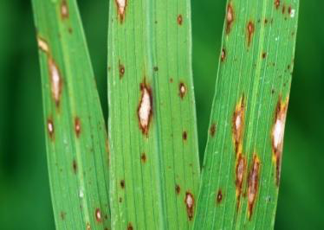

Fig 37

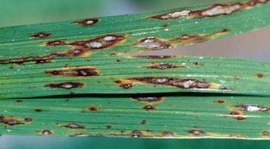

Fig 38 Nodal blast

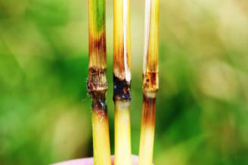

Fig39 Panicle blast/Neck blast

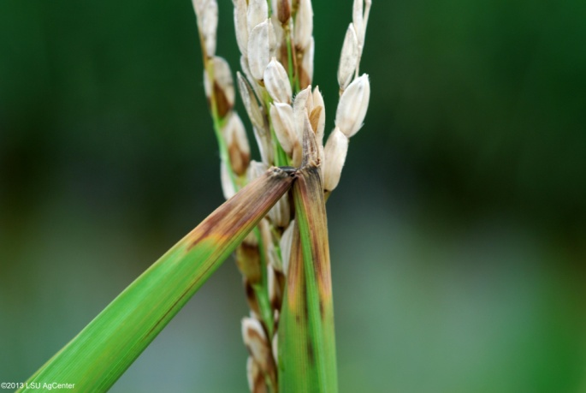

Fig40 Infected glumes

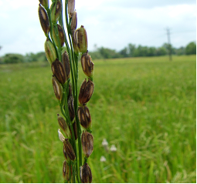

**Brown leaf spot**

Fig 41 Brown leaf spot-Initial stage

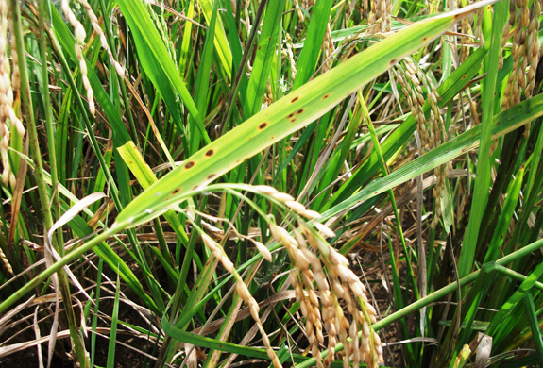

Fig42 Brown leaf spot advanced stage

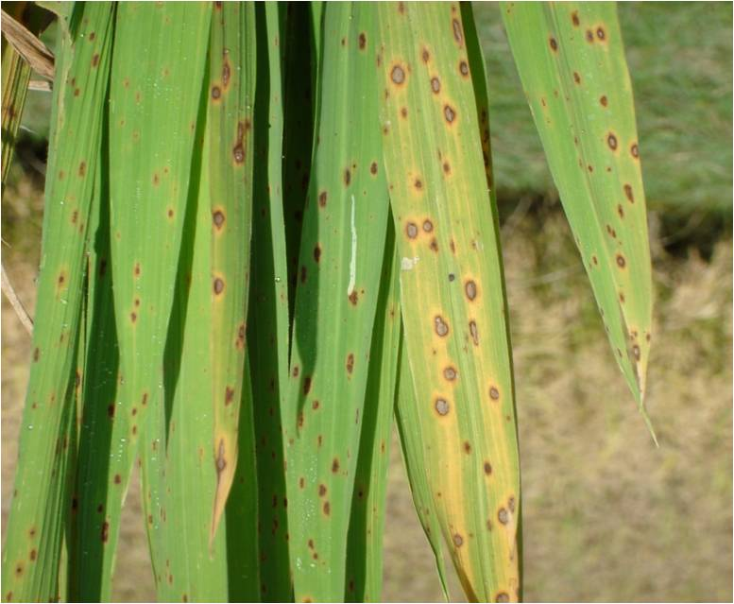

Fig 43 Brown spot symptoms on grain

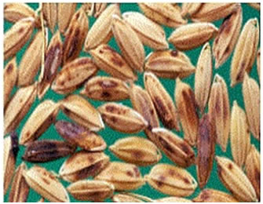

**Sheath blight**

Fig 44 Sheath blight infection initial stage

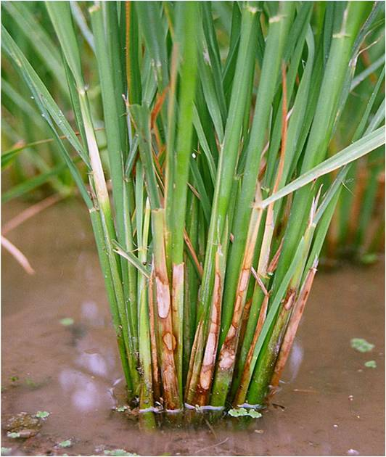

Fig 45 Sheath blight infection advanced stage

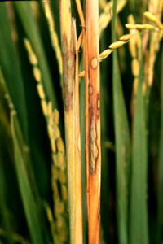

Fig 46 Sheath blight formation of sclerotia

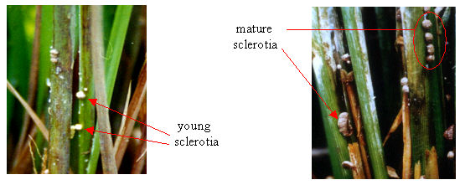

Fig 47 Flag leaf and panicle infection

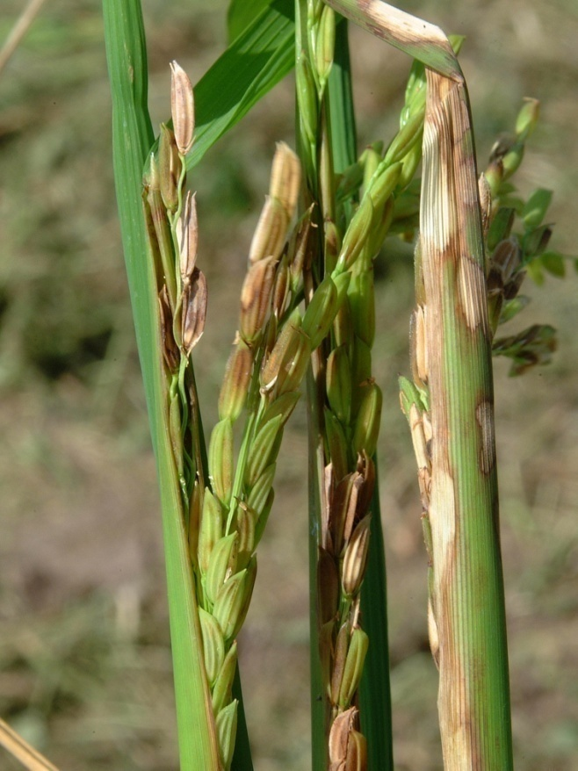

**Sheath Rot**

Fig 48 Sheath infection

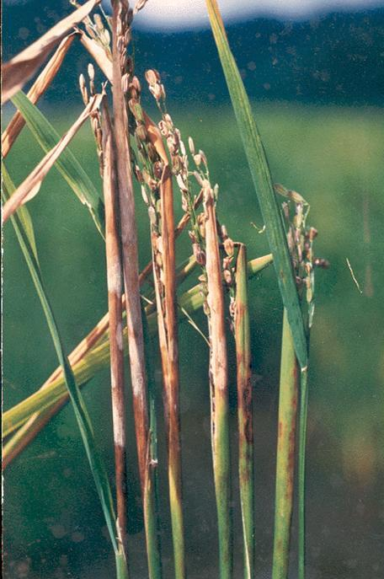

Fig 49 Chocking of panicle

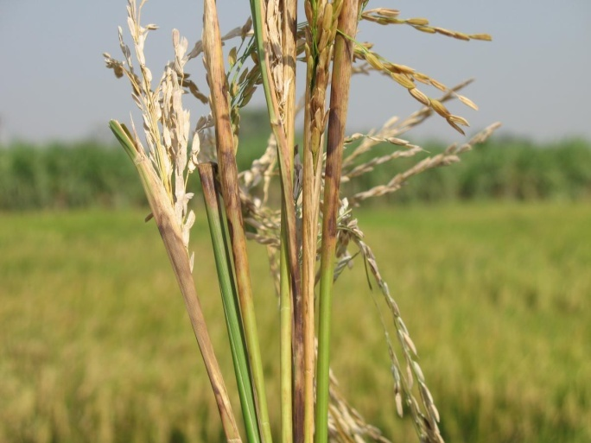

**False smut**

Fig 50 Infected grain-initial stage

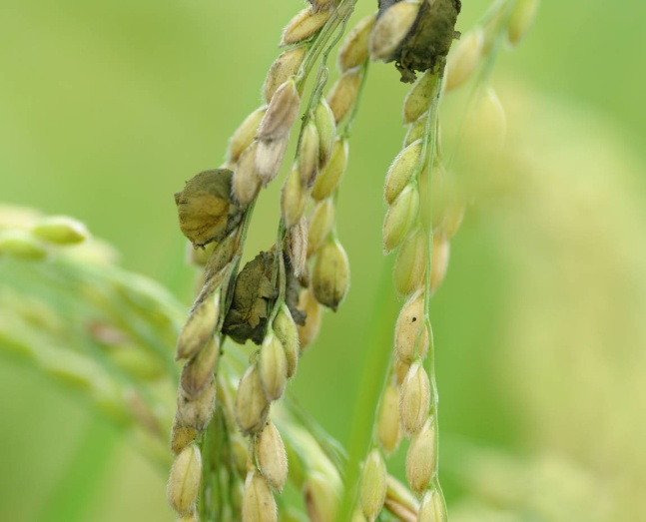

Fig,51 False smut infected panicle

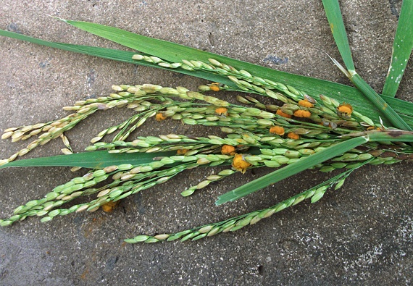

Fig 52 A close up of the infected grain

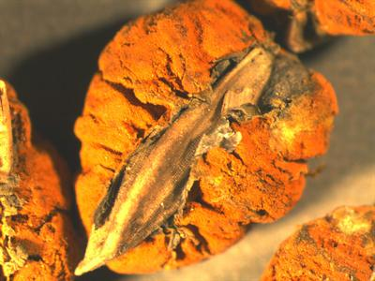

**Fig 53Udbatta**

**Bacterial Leaf Blight**

Fig 54 BLB Systemic infection-Kresek

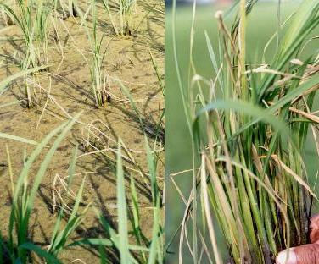

Fig 55 BLB Leaf symptom

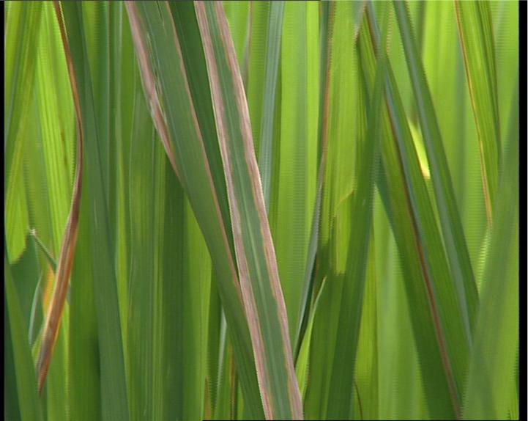

Fig 56 BLB Field symptom-Adavanced stage

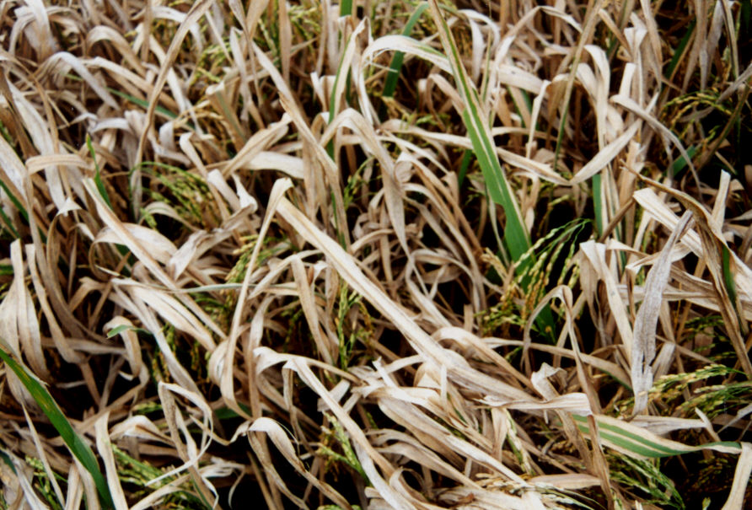

Fig 57 Bacterial ooze on leaf surface

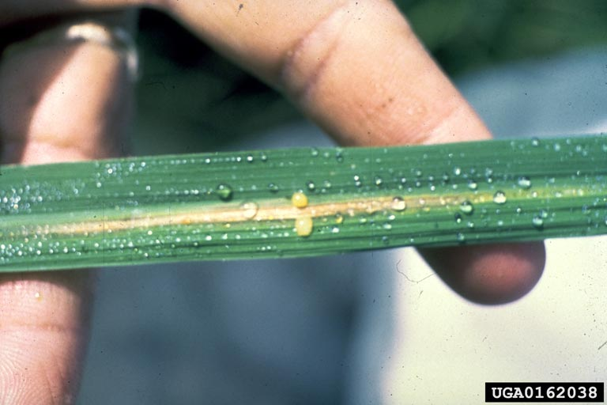

Fig 58 Ooze test to detect bacterial infection

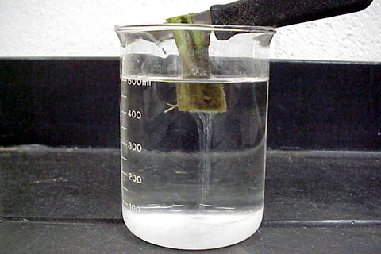

**Bacterial leaf streak**

Figs 59 Bacterial leaf streak -

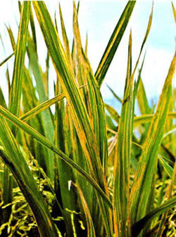

Figs60 Bacterial leaf streak-close up of an infected leaf

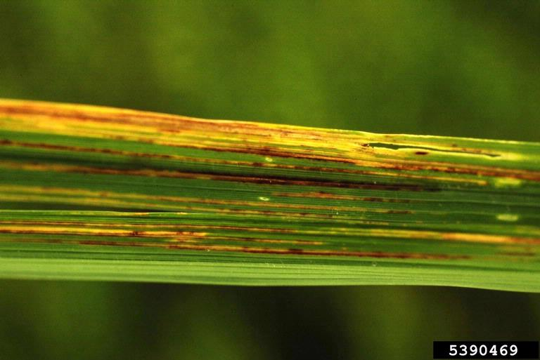

**Tungro**

Fig 61Leaf and field symptom

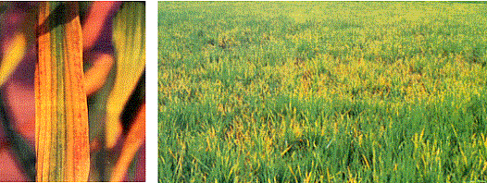

Fig 62 Tungro infected plant-General Stunting

